<https://www.youtube.com/watch?v=esKi_iWqb6M>

**Sketch** > **Include Library** > **Manage Libraries**

Search for “**LoRa**“.

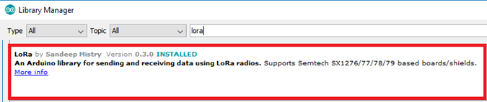

**#include <SPI.h>**

**#include <LoRa.h>**

|  |  |  |
| --- | --- | --- |
| **Setup** | **Send** | **Receive** |
| //433E6 for Asia  //866E6 for Europe/Africa  //915E6 for North America  **void** setup() {  Serial.begin(9600);  **if** (!LoRa.begin(868E6)) {  Serial.println("LoRa failed!");  Delay(1000);  }  LoRa.setSyncWord(*0xF3*);  LoRa.setTxPower(20);  } | int t = 20;    LoRa.beginPacket();  LoRa.print("Temp: ");  LoRa.print(t);  LoRa.endPacket();  delay(5000); | String LoRaData;  **int** packetSize = LoRa.parsePacket();  **if** (packetSize)  {  **while** (LoRa.available())  {  LoRaData = LoRa.readString();  Serial.print(LoRaData);  }  // print RSSI of packet  Serial.print("' with RSSI ");  Serial.println(LoRa.packetRssi()); |